Student Name:Swathi StudentID: : 15333576

Unit Code | Attendance Date | Training Location | Type of Contract:  . Face to Face  . Phone Support  . Email Support | Student Signature | Staff Initial
CHCECE056 |  |  |  | 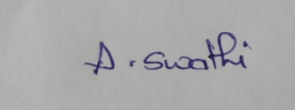
HLTAID012 |  |  |  | 
HLTWHS001 |  |  |  | 
CHCECE055 |  |  |  | 
CHCPRT001 |  |  |  | 
BSBWRT311 |  |  |  | 
CHCECE033 |  |  |  | 
CHCECE037 |  |  |  | 
CHCECE031 |  |  |  | 
CHCECE34 |  |  |  | 
CHCECE032 |  |  |  | 
CHCECE030 |  |  |  | 
CHCECE054 |  |  |  | 
CHCDIV001 |  |  |  | 
CHCECE035 |  |  |  | 
CHCECE036 |  |  |  | 
CHCECE038 |  |  |  | 

